Cyclistic Bike-Share Case Study

How Does a Bike-Share Navigate Speedy Success?
Prepared by: Raymos Gonzales -Junior Data Analyst, Cyclistic Marketing Analytics Team Date: August 2026 Tools: Python (pandas, matplotlib)

1. Ask — Business Task
Business task: Identify how annual members and casual riders use Cyclistic bikes differently, so the marketing team can design a strategy that converts casual riders into annual members.
Cyclistic’s finance analysts have concluded that annual members are significantly more profitable than casual riders. Lily Moreno, Director of Marketing, believes future growth depends on maximizing annual memberships — and that converting existing casual riders is a stronger opportunity than acquiring brand-new customers, because casual riders already know and use the service.
Key stakeholders: Lily Moreno (Director of Marketing), the Cyclistic marketing analytics team, and the Cyclistic executive team, who must approve any recommended marketing program.
Guiding question assigned: How do annual members and casual riders use Cyclistic bikes differently?

2. Prepare — Data Sources
- Source: Divvy historical trip data, made public by Motivate International Inc. under the Divvy Data License Agreement. (Divvy is the real Chicago bike-share system on which the fictional Cyclistic is based.)
- Datasets used (course starter files): Divvy_Trips_2019_Q1.csv (365,069 rides) and Divvy_Trips_2020_Q1.csv (426,887 rides).
- Organization: Each file is one row per ride, with ride ID, start/end timestamps, start/end station names and IDs, and rider type (usertype in 2019; member_casual in 2020).
- Credibility (ROCCC): The data is Reliable (system-generated station logs), Original (first-party operator data), Comprehensive (every trip in the system), Current (within the course’s intended scope), and Cited (publicly licensed by Motivate International).
- Privacy/licensing: Data contains no personally identifiable information; riders cannot be linked across purchases, so repeat casual-rider behavior cannot be tracked at the individual level. This is a known limitation.
- Known problems: The two quarters use different schemas and rider-type labels, and the data covers winter/early-spring months only, so seasonal conclusions are limited to Q1.

3. Process — Cleaning Documentation
All cleaning was performed in Python (pandas). Steps taken:
- Standardized schemas. Renamed 2019 Q1 columns to match the 2020 Q1 schema (trip_id → ride_id, start_time → started_at, end_time → ended_at, station columns aligned).
- Recoded rider types. Mapped 2019 usertype values (Subscriber → member, Customer → casual) so both quarters use the same member_casual categories.
- Merged quarters into a single dataframe of 791,956 rows, keeping ride ID, timestamps, stations, and rider type.
- Engineered fields:
  - ride_length_min = ended_at − started_at (in minutes)
  - day_of_week, hour, and month derived from started_at
- Validated and filtered:
  - Parsed timestamps; dropped rows with unparseable/missing values.
  - Removed rides under 1 minute (likely false starts/dock errors) and over 24 hours (outliers/unreturned bikes).
- Result: 783,778 clean rides (8,178 rows removed, ~1.0%), split 716,381 member rides and 67,397 casual rides.

4. Analyze — Summary of Analysis
Descriptive statistics and pivot-style aggregations comparing casual riders and members:
Metric | Casual riders | Annual members
Total rides (cleaned) | 67,397 | 716,381
Average ride length | 38.5 min | 11.5 min
Median ride length | 23.2 min | 8.5 min
Share of rides on weekends | 47.3% | 16.6%
Peak riding hours | Midday / afternoon (10am–3pm) | Commute peaks (7–9am and 4–6pm)
Key observations:
- Casual riders ride ~3.3× longer than members (38.5 vs 11.5 minutes on average) — consistent with leisure use vs. short utilitarian trips.
- Members are weekday commuters. Member volume peaks Tuesday–Thursday and shows sharp morning (8am) and evening (5pm) spikes.
- Casual riders are weekend leisure riders. Casual volume roughly triples on weekends, with nearly half of all casual rides occurring Saturday–Sunday.
- Casual rides cluster around tourist and lakefront destinations. The top casual start stations are Streeter Dr & Grand Ave, Lake Shore Dr & Monroe St, Shedd Aquarium, Millennium Park, and Adler Planetarium — Chicago’s leisure corridor.
- Casual ridership is growing faster. In Q1 2019 casual riders were ~7% of rides; by Q1 2020 (especially March 2020) casual volume grew markedly year-over-year (Feb: 2,627 → 12,206 rides), suggesting an expanding conversion pool.

5. Share — Key Findings and Visualizations
Finding 1 — Two fundamentally different use cases. Members use Cyclistic as transportation; casual riders use it as recreation. 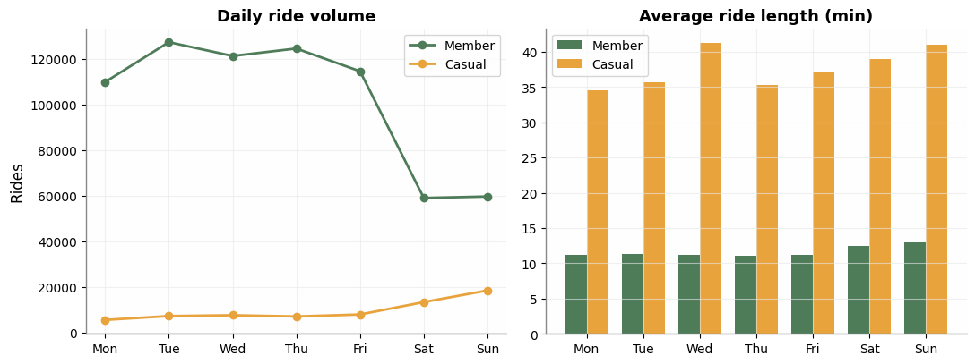
Finding 2 — Timing is the biggest behavioral gap. Members ride in commute peaks on weekdays; casual riders ride leisurely midday hours, concentrated on weekends. 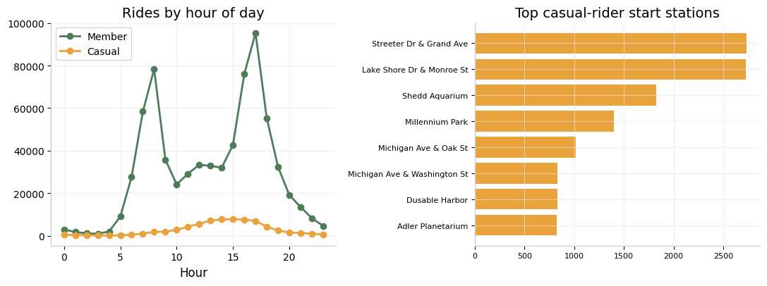
Finding 3 — Casual riders start where tourists and weekenders gather. Conversion marketing placed at lakefront stations reaches casual riders exactly where they already ride. 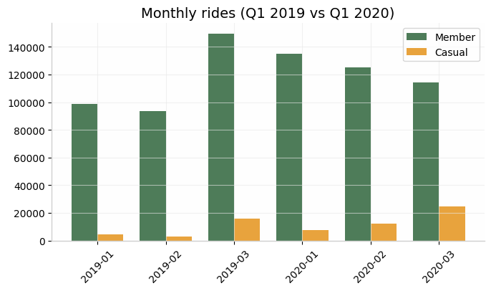
The story the data tells: Cyclistic already owns the leisure rider’s weekend. The marketing opportunity is to show weekend riders that an annual membership pays for itself in just a few leisure rides — and to do it at the stations and times where they actually ride.

6. Act — Top Three Recommendations
- Weekend-focused conversion campaign at leisure hotspots. Run targeted digital ads and on-site promotions at the top casual stations (Streeter Dr & Grand Ave, Lake Shore Dr & Monroe St, Millennium Park, museum campuses) on Saturdays and Sundays, when casual ridership peaks. Messaging should anchor on value: “Your weekend rides already cost more than a membership.”
- Introduce a leisure-oriented membership tier or trial. Casual riders average 38-minute recreational rides — very different from the member commute profile. Offer a “Weekend Explorer” trial (e.g., a discounted first 3 months, or a pass that converts accumulated day-pass spend into membership credit) to lower the barrier for riders who don’t commute.
- Use in-app and post-ride digital nudges tied to ride behavior. Because casual rides are long and midday/weekend-based, trigger push notifications or emails after a casual rider’s long weekend ride showing their per-ride cost vs. membership cost, with a one-tap upgrade. Time retargeting ads for Thursday–Friday, when weekend leisure plans are made.
Suggested next steps for deeper analysis: analyze a full 12 months to capture summer seasonality (the strongest casual-riding season), survey casual riders on membership barriers, and — if privacy-compliant data becomes available — identify repeat casual riders as the highest-priority conversion segment.

Appendix: Analysis performed with Python/pandas on the Divvy 2019 Q1 and 2020 Q1 datasets; all cleaning steps documented in Section 3. Data © Motivate International Inc., used under the Divvy Data License Agreement.

